FIRES at IECER2017

Mark Sanders

Document Identifier
Report on IECER 2017 conference September 20-22 2017, Siegen, Germany.

Version
1.0

Date Due
M36

Submission date
25-09-2017

WorkPackage
7

Lead Beneficiary
UU

Place, Date and Time
Siegen, 20-21-22 September 2017, 9:00-17:00

Stakeholders
Over 50 delegates from all over the world attending the 15th annual Interdisciplinary European Conference on Entrepreneurship Research. The attendants are all scientists interested in entrepreneurship. At the conference, the FIRES-project contributed a track with papers from the project and from ongoing academic work on topics related to entrepreneurial venturing.

Format
The program of the conference can be found here. The general format is standard. Some excellent keynotes and plenary sessions but most of the discussion taking place in a series of high quality parallel sessions in which FIRES-researchers presented their papers (in about 20 mins) giving the audience the opportunity to make suggestions, comments and give feedback in a 10 minute discussion.

Main Question(s) put to the Stakeholder(s)
The question put to the colleagues was very broadly: “what do you think?”. As the material presented was in a more or less final stage, the comments were focused on improving the analyses and discussing the implications of our work for institutional change.

Executive summary
Overall, the conference helped us position the FIRES-project in the broader field of entrepreneurship research. In the text below we report briefly on the discussion and feedback the respective FIRES-papers received in the conference.

Werner Liebregts On the Macroeconomic benefits of Entrepreneurial talent inside the Firm (Th 13:30-15:45)

This paper is a first attempt to also include entrepreneurship inside established firms (i.e. intrapreneurship) in models explaining national-level economic growth. We find that the role of entrepreneurial employees in society is at least as important as that of independent entrepreneurs. Moreover, the empirical analyses especially demonstrate the importance of easy access to sound money and limited freedom to trade internationally for entrepreneurial activity by employees to contribute to countries' economic performance. The audience was generally supportive of the paper, its approach and findings and provided some useful comments as to further improve the paper. For example, regarding the explanation for one of the somewhat puzzling finding that trade liberalisation negatively affects growth through intrapreneurship. This finding was discussed extensively and some useful policy implications were brought into the discussion. These comments will be taken into account when finalizing the conclusions and discussion section of the paper.

Davide Hahn Economic and Societal Venture Performance as Driver of Entrepreneurial Satisfaction (Th 13:30-15:45)

Not a FIRES-consortium member, Davide Hahn from University of Bergamo presented his work on an alternative and important entrepreneurship outcome variable: satisfaction. He showed that entrepreneurs, especially young entrepreneurs in academic environments, of course derive satisfaction from economic performance of their ventures, but also from social and community impact. This implies that not all the rewards to entrepreneurship are monetary and by implication, the motivation for entrepreneurial venturing need not only come from commercial opportunity. Hahn’s research also shows that this motivation is significantly influenced by the environment in which entrepreneurs operate. In more successful universities (measured by having more spinouts), they tend to value commercial success higher and social impacts lower. His insights are useful for the FIRES project to take into account when formulating proposals on academic entrepreneurship and fostering entrepreneurial cultures in general.
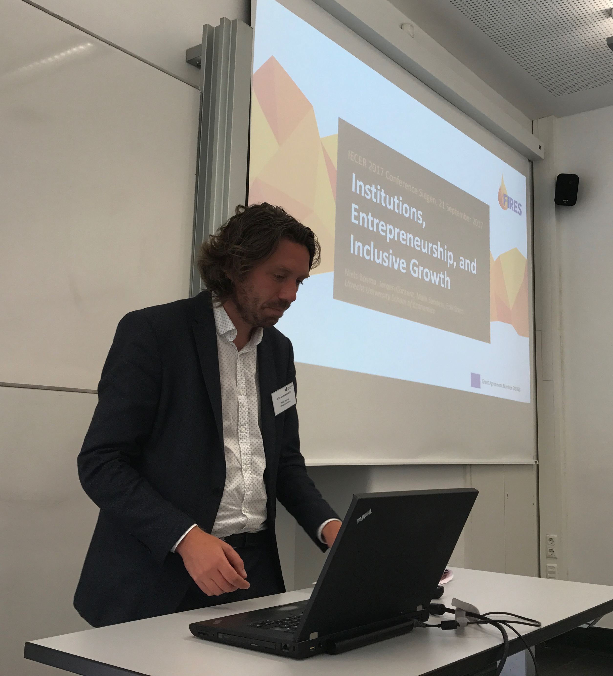

Niels Bosma Institutions, Entrepreneurship and Inclusive Growth (Th 13:30-15:45)

The paper links institutions to entrepreneurial activity and various growth indicators and shows that entrepreneurship positively correlates with economic growth in the European Union. Institutions that are found to significantly strengthen this link are Start-up skills, government size (negative) and business friendly regulation. The audience accepted the proposed data and methods and raised several questions for clarification. This will help finalize the report and be more explicit about the interpretation of results obtained.

Tamara Naulin Coopetition as a Success Strategy for Startups in Business Accelerators (Th 13:30-15:45)

Tamara Naulin is a PhD student at Heinrich Heine University in Düsseldorf, Germany. She presented a work in progress paper in the FIRES-track to collect feedback and suggestions on how to proceed. The proposed research on the balance between cooperation and competition in incubators and accelerators is highly topical and interesting and takes the institutions for entrepreneurship debate down to the day-to-day practice of incubators and accelerators and the teams shaping the culture and atmosphere in these hotspots of entrepreneurial venturing. Her preliminary results showed that cultures across incubators/accelerators differ markedly. Some are rather extremely competitive and have little cooperation, some the reverse, but interestingly many try to foster both. Hence the term coopetition. Some competition is rewarding and motivating whereas cooperation seems an important reason for start-ups to go into an incubation program in the first place. Unfortunately, results do not yet allow for any inferences on what drives the success of incubators and accelerators more and what the policy implications of this research are, will remain to be researched. The discussion in the room focused on the question what start-ups in an incubator are competing over and cooperating on.

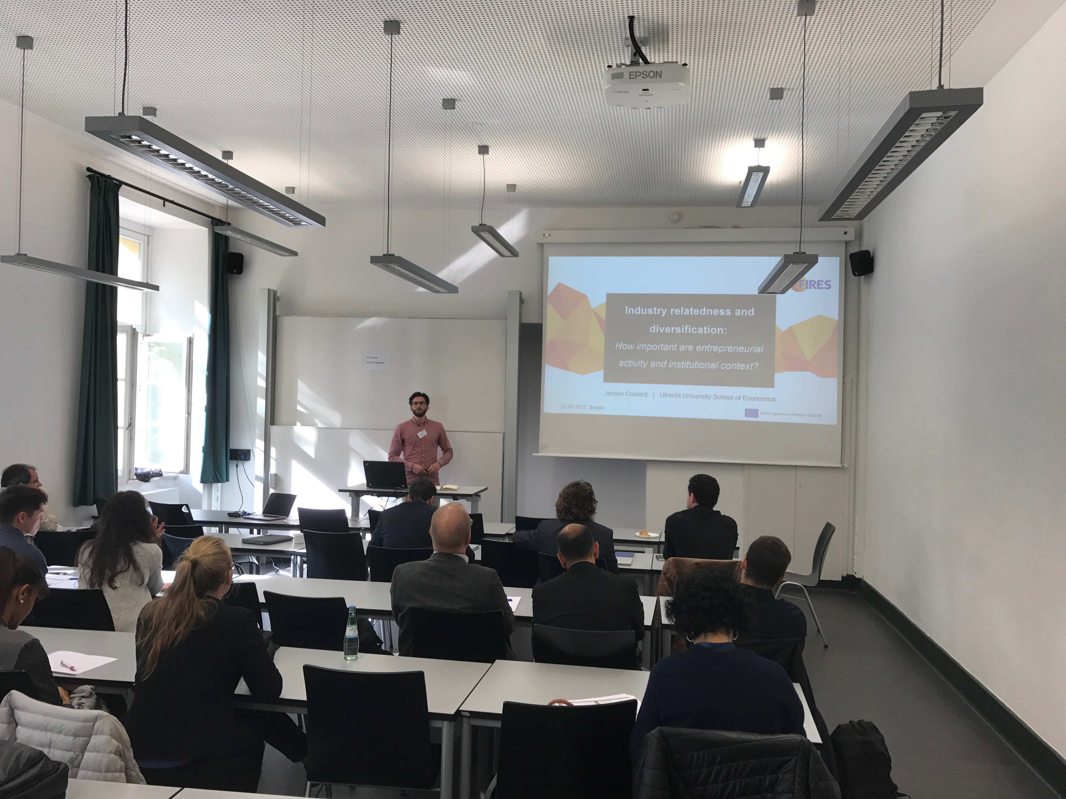
Jeroen Content Industry Relatedness and Regional Diversification (Th 13:30-15:45)
The paper presented investigates the role of institutional contexts and entrepreneurial activity in the national diversification of economies in Europe. The empirical results show that liberal market economies and countries with more liberal institutions have a higher probability of diversifying into unrelated varieties. Coordinated market economies in contrast, are more likely to pursue diversification strategies in related varieties. Entrepreneurship in both context helps to diversify in unrelated varieties. To maintain Europe’s position in global competition and make the European economy more resilient to sector specific shocks, it is important to promote entrepreneurship across institutional contexts, but how this is to be done, is context specific. The audience engaged in a lively discussion and the suggestion was made to also control for natural resources in driving specialization patterns. This suggestion will be explored in finalizing the paper.

Follow Up
The comments specific to the papers mentioned above have been discussed in the author teams and have been addressed to improve the scientific quality of our work. The IECER conference organisation requested we also participate in future IECER conferences with contributed tracks. The interest and discussion on the Entrepreneurial Society has clearly taken root in the academic community.

