FIRES at WINIR2017

Mark Sanders

Document Identifier
Report on WINIR 2017 conference September 14-16 2017, Utrecht.

Version
1.0

Date Due
M36

Submission date
17-09-2017

WorkPackage
7

Lead Beneficiary
UU

Place, Date and Time
Utrecht, 14-15-16 September 2017, 9:00-17:00

Stakeholders
Over 200 delegates from all over the world attending the WINIR annual conference on “Institutions and Open Societies”. The attendants are all scientists interested in institutional development and change. At the conference, the FIRES-project filled several parallel sessions with papers from the project and from ongoing academic work on topics related to institutional preconditions and reforms for entrepreneurial venturing.

Format
The program of the conference can be found here. The general format is standard. Some excellent keynotes and plenary sessions but most of the discussion taking place inn a series of high quality parallel sessions in which FIRES-researchers presented their papers (in about 20 mins) giving the audience the opportunity to make suggestions, comments and give feedback in a 10 minute discussion.

Main Question(s) put to the Stakeholder(s)
The question put to the colleagues was very broadly: “what do you think?”. As the material presented was in a more or less final stage, the comments were focused on improving the analyses and discussing the implications of our work for institutional change.

Executive summary
Overall, the conference helped us position the FIRES-project in the broader discussion on the importance of maintaining open societies and prevent institutional closing up. In the text below we report briefly on the discussion and feedback the respective FIRES-papers received in the conference.

Niklas Elert Entrepreneurship and institutions: a bidirectional relationship (Fr 9:00-10:30)
In this paper, a fundamental insight in the FIRES-project, that institutions and entrepreneurship are interacting and causation does not run in one direction only, was proposed to the audience. The evidence was deemed convincing and the possibility of entrepreneurs contesting and in the end also shaping new institutions was discussed. Entrepreneurs can strengthen existing institutional arrangements by conforming with them, but they can also undermine and eventually change them by first evading and then upsetting them (e.g. Uber, Fintech). A question for policy makers is what to do about such entrepreneurs. On the one hand, it is unnatural to stimulate them upsetting the very institutions policy makers have helped to build in the past. On the other, it is important to be flexible and responsive to keep markets and systems open to challengers as these challengers drive innovation. The discussion was not resolved but the need for open minded policy makers with a clear understanding of the true public interest, was underscored.

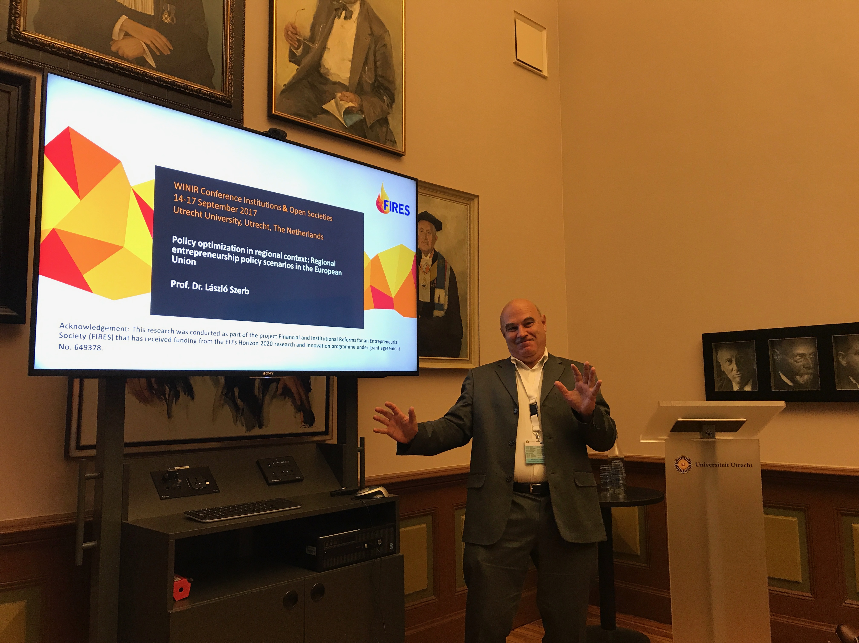
Laszlo Szerb Resource optimization in regional context: regional entrepreneurship scenarios in the European Union (Fr 9:00-10:30)

The presentation builds on the Regional Entrepreneurship and Development Index (REDI) that provides a holistic view to the functioning of EU's Regional Entrepreneurship Ecosystems (ES) and can be used as efficient policy design framework. We use the REDI to explore different policy scenarios in 125 EU regions. The basic scenario targets an increase by 5 points in each region. The second optimizes the input allocation by prioritizing regions that provide the largest increase in the REDI score (most efficient version). The third distributes the additional inputs based on EU Cohesion Funds 2013-4 allocation (increased regional convergence version). The results of the simulations imply that the loss of efficiency could exceed 30% when we move form an optimal (most efficient) solution to a more equity favoured version. EU should make a decision to direct its inputs to decrease the gap in entrepreneurship between the EU and the US by moving to the optimal input allocation or should pay a price in a more equalizing but lower efficiency solution. In the latter case, ES differences between the US and EU is expected to increase.
In the question/comment section there were some questions about the entrepreneurship ecosystem view and about the used regional classifications and borders.

Gresa Latifi Institutional determinants of venture capital: taking social capital to a front seat (Fr 11:00-12:30)
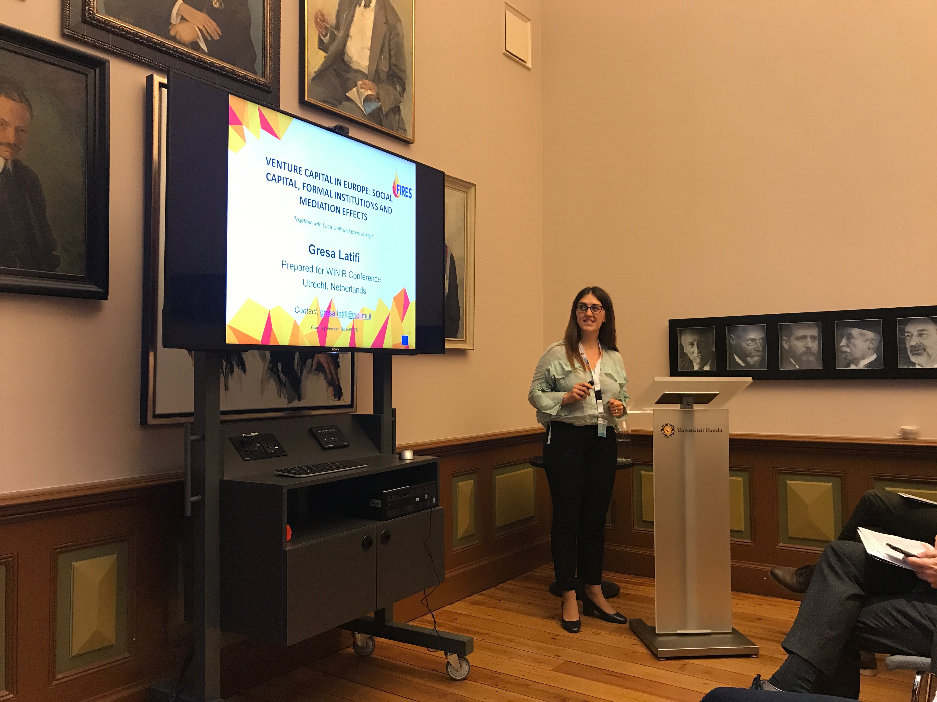
The paper presented in WINIR stands as a half formal FIRES-deliverable document. It tries to give an answer whether the various development and performance of Venture Capital (VC) activity across different areas roots from informal institutional dimension. Centering in a purely European setting, this study initially explores if the “standard suspects” mostly embodied inchangeable formal institutions (investors protection laws, taxation regulations, labour market regulations) do really play a role for having a solid venture capital industry. In addition, it explores whether or not these drivers are thorough determinants of VC activity, or conversely, informal institutions, and specifically social capital, may apply a noticeable impact. What we learned is that social capital indirectly effects VC activity, i.e. by molding the formation of structural formal institutions, which in turn affect VC activity. The policy makers therefore should bear in mind the characteristics of informal institutions (i.e. social capital) within which they operate, so that they can frame more prosperous institutional conditions (taxations) for the VC in the short and long terms. The latter became a discussion point in the conference, whether policy makers should be advised for a “rethought tax deduction incentive” or not (due to costs from a welfare perspective). What can be clearly stated is that this work does not chase a “general-equilibrium” analysis, it rather documents that taxation is a more effective mechanism (compared to other institutional forms) for increasing the level of VC activity, and not automatically for economic development.

Miguel Amaral Senior entrepreneurship and institutions: contributions from Portugal (Fr 11:00-12:30)

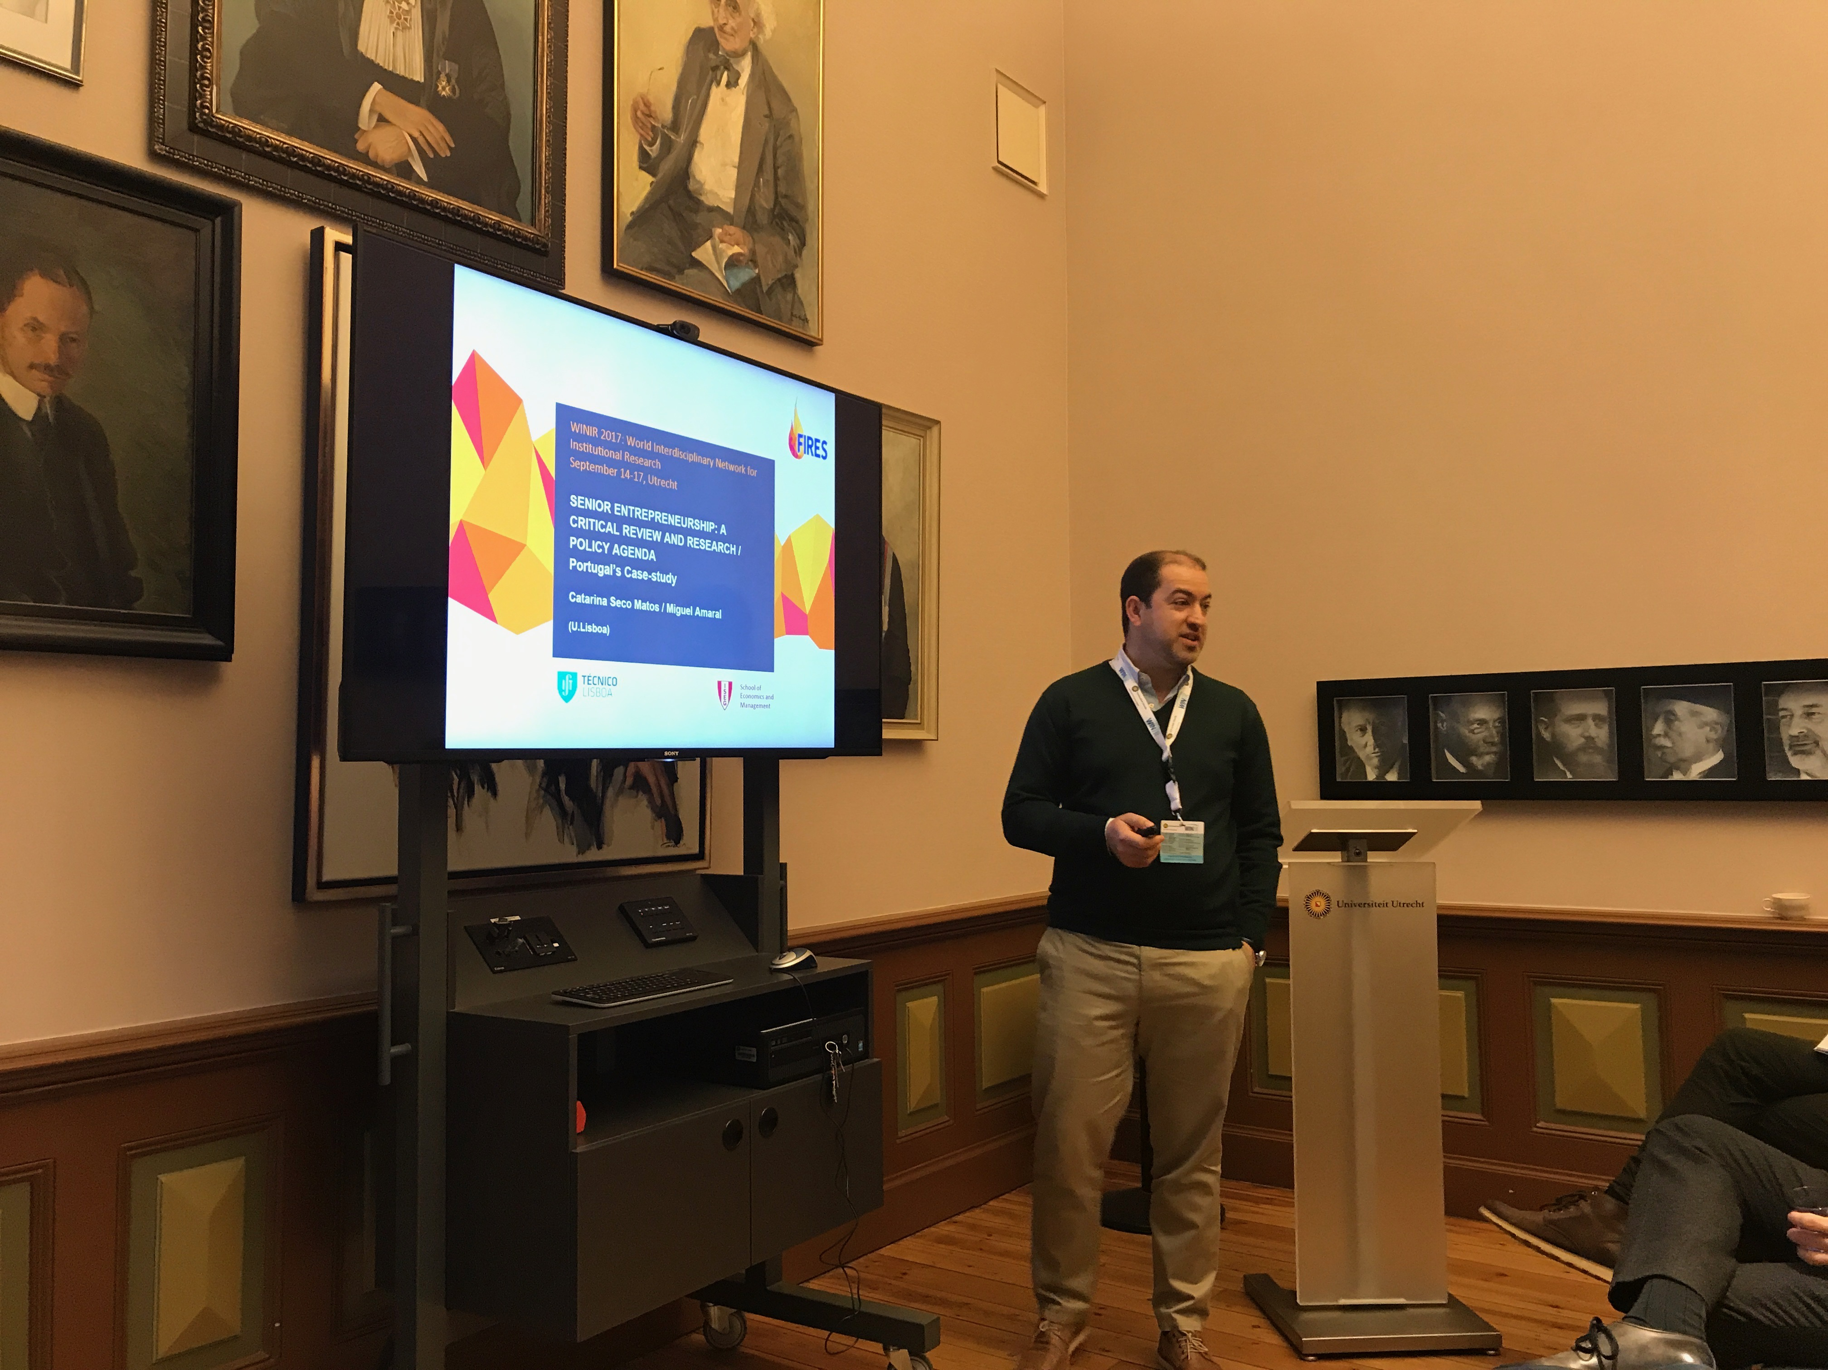
The present paper proposes and discusses a preliminary research and policy agenda on senior entrepreneurship, with focus on the Portuguese case. The paper is organized into six key research questions, namely: (i) Why is Senior Entrepreneurship important? (ii) What is the current Knowledge & Academic Research available (and still lacking) on Senior Entrepreneurship? (iii) What are the key supporting initiatives available for Senior Entrepreneurs in the world? (iv) Are academics producing research on Senior Entrepreneurship with practical policy implications? (v) Are policies and supporting initiatives backed up by scientific knowledge? (vi) How can we produce and use adequate knowledge and policies towards Senior Entrepreneurship in Europe (particularly in Portugal)? In order to address the previous questions and to shed light on how institutions may better support senior entrepreneurship, we draw on a number of research pieces developed/under development by the authors, specifically: (a) a recent and comprehensive Systematic Review of Literature – working paper; (b) analysis of international programs and initiatives for senior entrepreneurs based on secondary data – working paper; (c) a thorough description of the Portuguese context based on primary data – published book; (d) a study of firm entry and growth by senior entrepreneurs , based on secondary data – working paper and (e) a study on senior entrepreneurs’ satisfaction, based on primary data – under revision at a scientific journal. Particular focus was put on Human capital, Social capital, Information and Communication, Research and Funding, in order to discuss the interplay between Academic Research / Available knowledge and Policymaking / Supporting Initiatives.

Emanuele Giraudo Can Variety of public subsidies alleviate the financial constraints of young innovative companies? Insights from the Startup Act in Italy (Fr 11:00-12:30)
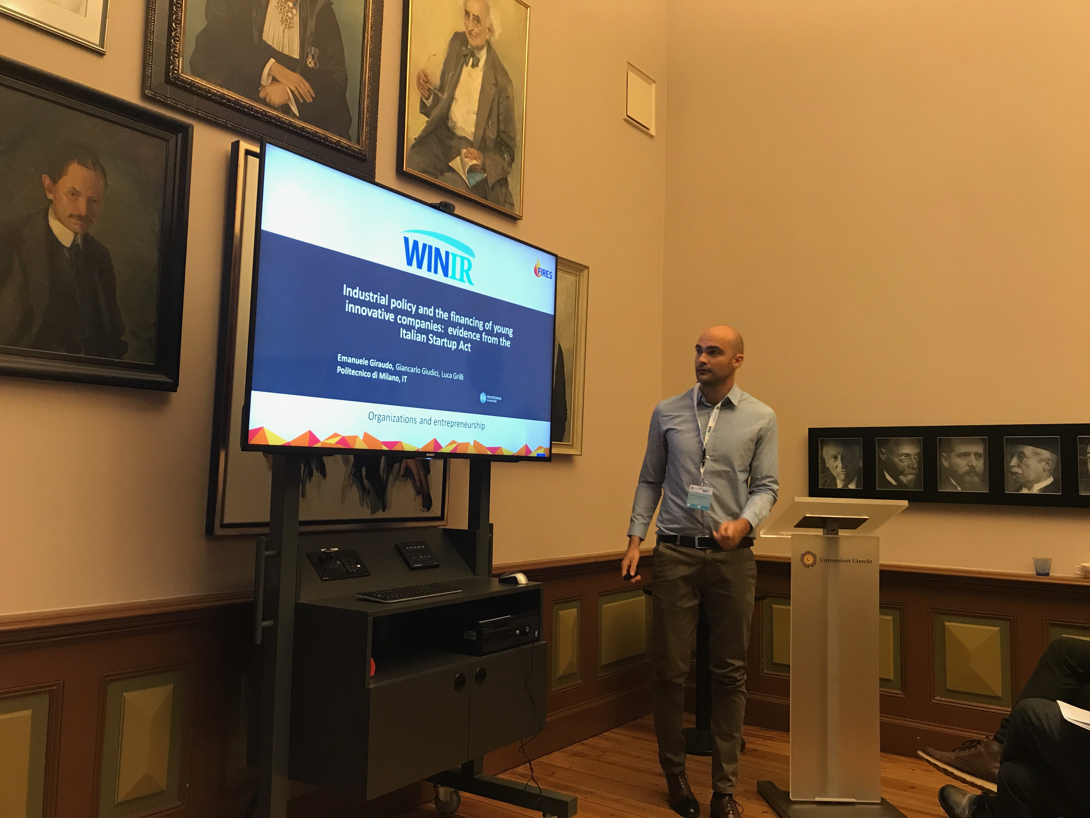
The paper, by taking advantage of the Italian Startup Act issued in 2012, analyses the possible existence of interrelationships between Young Innovative Companies (YICs) access to a government-guaranteed (GG) bank loan program and fiscal incentive for venture capital (VC) investment. Results highlight the significant reduction in the likelihood of being backed by a VC after the access to a GG bank loan and vice versa, suggesting a crowd-out effect between the two types of investors (and the underlying policy measures). In addition, the two mechanisms appear to be functional to different typologies of YICs speaking in favour of an "institutional division of labour" between the two measures.
During the discussion after the presentation some comments have highlighted the necessity to include in the set of variables the "performance" of the YICs financed by VC and GG Bank Loans, in order to evaluate on what kind of policy instrument the governments should focus more.

Michael Wyrwich Historical shocks and persistence of economic activity: evidence from a unique natural experiment (Fr 11:00-12:30)
This paper is not a formal FIRES-deliverable. The paper is work in progress and investigates the persistence of regional differences of entrepreneurship in a context where radical formal institutional changes took place. The empirical case area analysed in the project is the Kaliningrad exclave. The area experienced a number of disruptive shocks including devastation by World War II, nearly complete replacement of the native German population by Soviets, and 45 years under an anti-entrepreneurial socialist economic regime followed by transition to a market economy. We find a high level of persistence of industry-specific self-employment rates. The analysis suggests that persistence is higher in regions where a specific industry was particularly efficient and entrepreneurial activity was especially pronounced. Thus, one important mechanism behind persistence is the resurrection of historically successful entrepreneurship. The discussion that followed the presentation focused on potential alternative explanations for the persistence of entrepreneurship. Comments referred also to regional peculiarities and the history of the Kaliningrad area. In the end, there was an overall consensus that the results are definitely of great importance even though minor revisions are necessary to sharpen the argument.
The WINIR conference was very helpful to reach out to scientists in institutional economics and the history of institutions. The professional background of the conference attendees allowed for a fruitful discussion in the aftermath of my presentation but also more generally enhanced my perception of the role of institutions for economic activity and entrepreneurship in particular.

Mark Sanders Capitalist Dynamics and the Decline of the Open Society (Fr 13:30-16:00)

This paper is not a formal FIRES-deliverable. The paper is work in progress and models the cycle in the rise and fall of open society institutions Van Bavel (2016) links to the dynamics of capital accumulation and concentration in market economies. The model presented, teaches us that the existence of labour and capital markets can indeed cause the concentration of wealth in the hands of fewer people. This cycle can be broken by creating and maintaining open institutions that ensure access to knowledge and finance and empower individuals to resists wealthy individuals capturing political power. The discussion that followed, focused on the details of the model and the appropriateness of the modelling approach for such complex and rich historical analyses, but the conclusion was that modelling the most important mechanisms parsimoniously, clarifies how various key assumptions interact.

Selin Dilli Human Capital, gender and entrepreneurship (Sa 9:00-10:30)
This paper is on deliverable D2.4 that aims to understand the long-term cross-national differences in knowledge institutions and their relevance for entrepreneurial activity. Previous studies offer evidence that human capital obtained through education is a crucial explanation for cross-national differences in entrepreneurial activity. Recently, scholarly attention has focused on the importance of the choice of subjects such as Science, Technology, Engineering and Math (STEM) for the promotion of entrepreneurial activity. However, to our knowledge, empirical evidence on this link is scarce, despite the policy makers emphasis on the choice of study at the tertiary level. Given that difference in STEM education are particularly large between men and women, we utilize data for 19 European countries and the United States from the Global Entrepreneurship Monitor and study the role of these differences at the country level for three stages of the entrepreneurial process: entrepreneurial awareness, the choice of the sector for entrepreneurial activity and entrepreneurial growth aspirations. We also test whether the balance of the effects of gender differences in the education field is moderated by the nature of the institutional environment in which entrepreneurs operate. The findings of the paper show that individual-level explanations including education account for the gender differences in all three stages of early-stage entrepreneurial activity. Moreover, countries with greater gender equality in science education are characterized by higher entrepreneurial activity in knowledge-intensive sectors and high growth aspirations. Thus, next to individual-level education, closing the gender gap in science at the country level benefits the country as a whole by stimulating innovative entrepreneurial activity. The discussion that followed the presentation of the paper, focused on the overall level of gender equality of societies and their implications for the (gendered) entrepreneurial activity.

Selin Dilli Varieties of entrepreneurship: how national institutions shape entrepreneurial ecosystems across Europe (Sa 13:30-16:00)
This paper is not a formal FIRES-deliverable but was published in the FIRES-working paper series in an earlier version and will appear in the Small Business economics special issue on FIRES. The paper uses the literature on ‘Varieties-of-Capitalism’ (VoC), which offers a parsimonious theoretical framework to address questions such as: which institutions are most influential for entrepreneurial activity? How do national institutions relate to different types of entrepreneurship? And to what extent are institutions complementary to each other in the way they sustain different entrepreneurship types?. Based on the VoC literature, we theoretically derive a consistent set of institutional indicators that can explain differences in entrepreneurship types between countries. Based on principal component and cluster analyses, we illustrate how 21 Western developed economies cluster around four distinct institutional settings. Furthermore, we use simple OLS regressions to show how these institutional constellations are related to different types of entrepreneurship. We conclude that four different ‘Varieties of Entrepreneurship’ can be identified across the Western world. The discussion that followed the presentation of the paper, focused on the within national differences at the regional level and the policy tools each cluster of institutional constellations should follow to stimulate entrepreneurial activity. Moreover, there were also suggestions to include other types of entrepreneurial activity such as entrepreneurial employee activity and how this activity is linked with our clusters.

Koen Frenken The rise of the sharing economy as a process of institutional entrepreneurship (Sa 13:30-16:00)
Sharing platforms have raised controversy, in particular, because they claim that existing regulations in the markets they operate in, do not apply to sharing platforms and their participants. Hence, the platforms' institutional strategy is to try to avoid the institutional logic of states (product regulation) and professions (licences, diplomas). Instead, platforms frame their business as belonging either to the new institutional logic of "tech" and the older institutional logic of the family (that is, the private sphere). Drawing on the theory of institutional entrepreneurship (Battilana et al., 2009, The Academy of Management Annals 3), this paper investigates these strategies for five platforms in The Netherlands (SnappCar, Airbnb, UberPop, Airdnd, Helpling), and explains why these strategies increasingly differ from one another and why all, so far, have been quite successful. We will also discuss some implications for possible regulations in the near future, in particular, discussing the pros and cons of granting platforms a "Right to Challenge". Unfortunately, due to family circumstances, Koen was not able to present the paper in the conference. Still the discussion in this session did touch on the Battilana 2009 paper and included an extensive discussion of the literature that followed this paper that founded the field of institutional entrepreneurship. Relevant conclusion for the FIRES consortium is that institutional entrepreneurs can be both strengthening and evading existing institutions. Especially the latter type needs attention and protection from vested interests, to maintain a dynamic and open economy.

Andrea Herrmann How labour markets institutions influence team startup firms (Sa 13:30-16:00)
This paper is part of the scientific deliverables of WP5. As required by deliverable 5.1, the “Manuscript […. is ] focusing on labour”. More concretely, it investigates the link between labour-market institutions and team formation processes in start-up companies. While existing entrepreneurship research stipulates that national institutions impact on the behaviour of start-up firms, cross-national studies investigating this link hardly exist. Questions about the ways and moments in which national institutions influence the formation of start-up teams thus remain unanswered.
To address this research gap, the paper analyses the start-up processes of 344 ventures in Germany and the US, offering particularly typical examples of countries with regulated and deregulated labour-market institutions respectively. Based on optimal matching techniques, the paper illustrates how team formation processes differ over time in terms of founder and employee involvement and the hiring of service providers. Binary logistic regressions are used to identify the extent to which national labour-market institutions account for these differences.
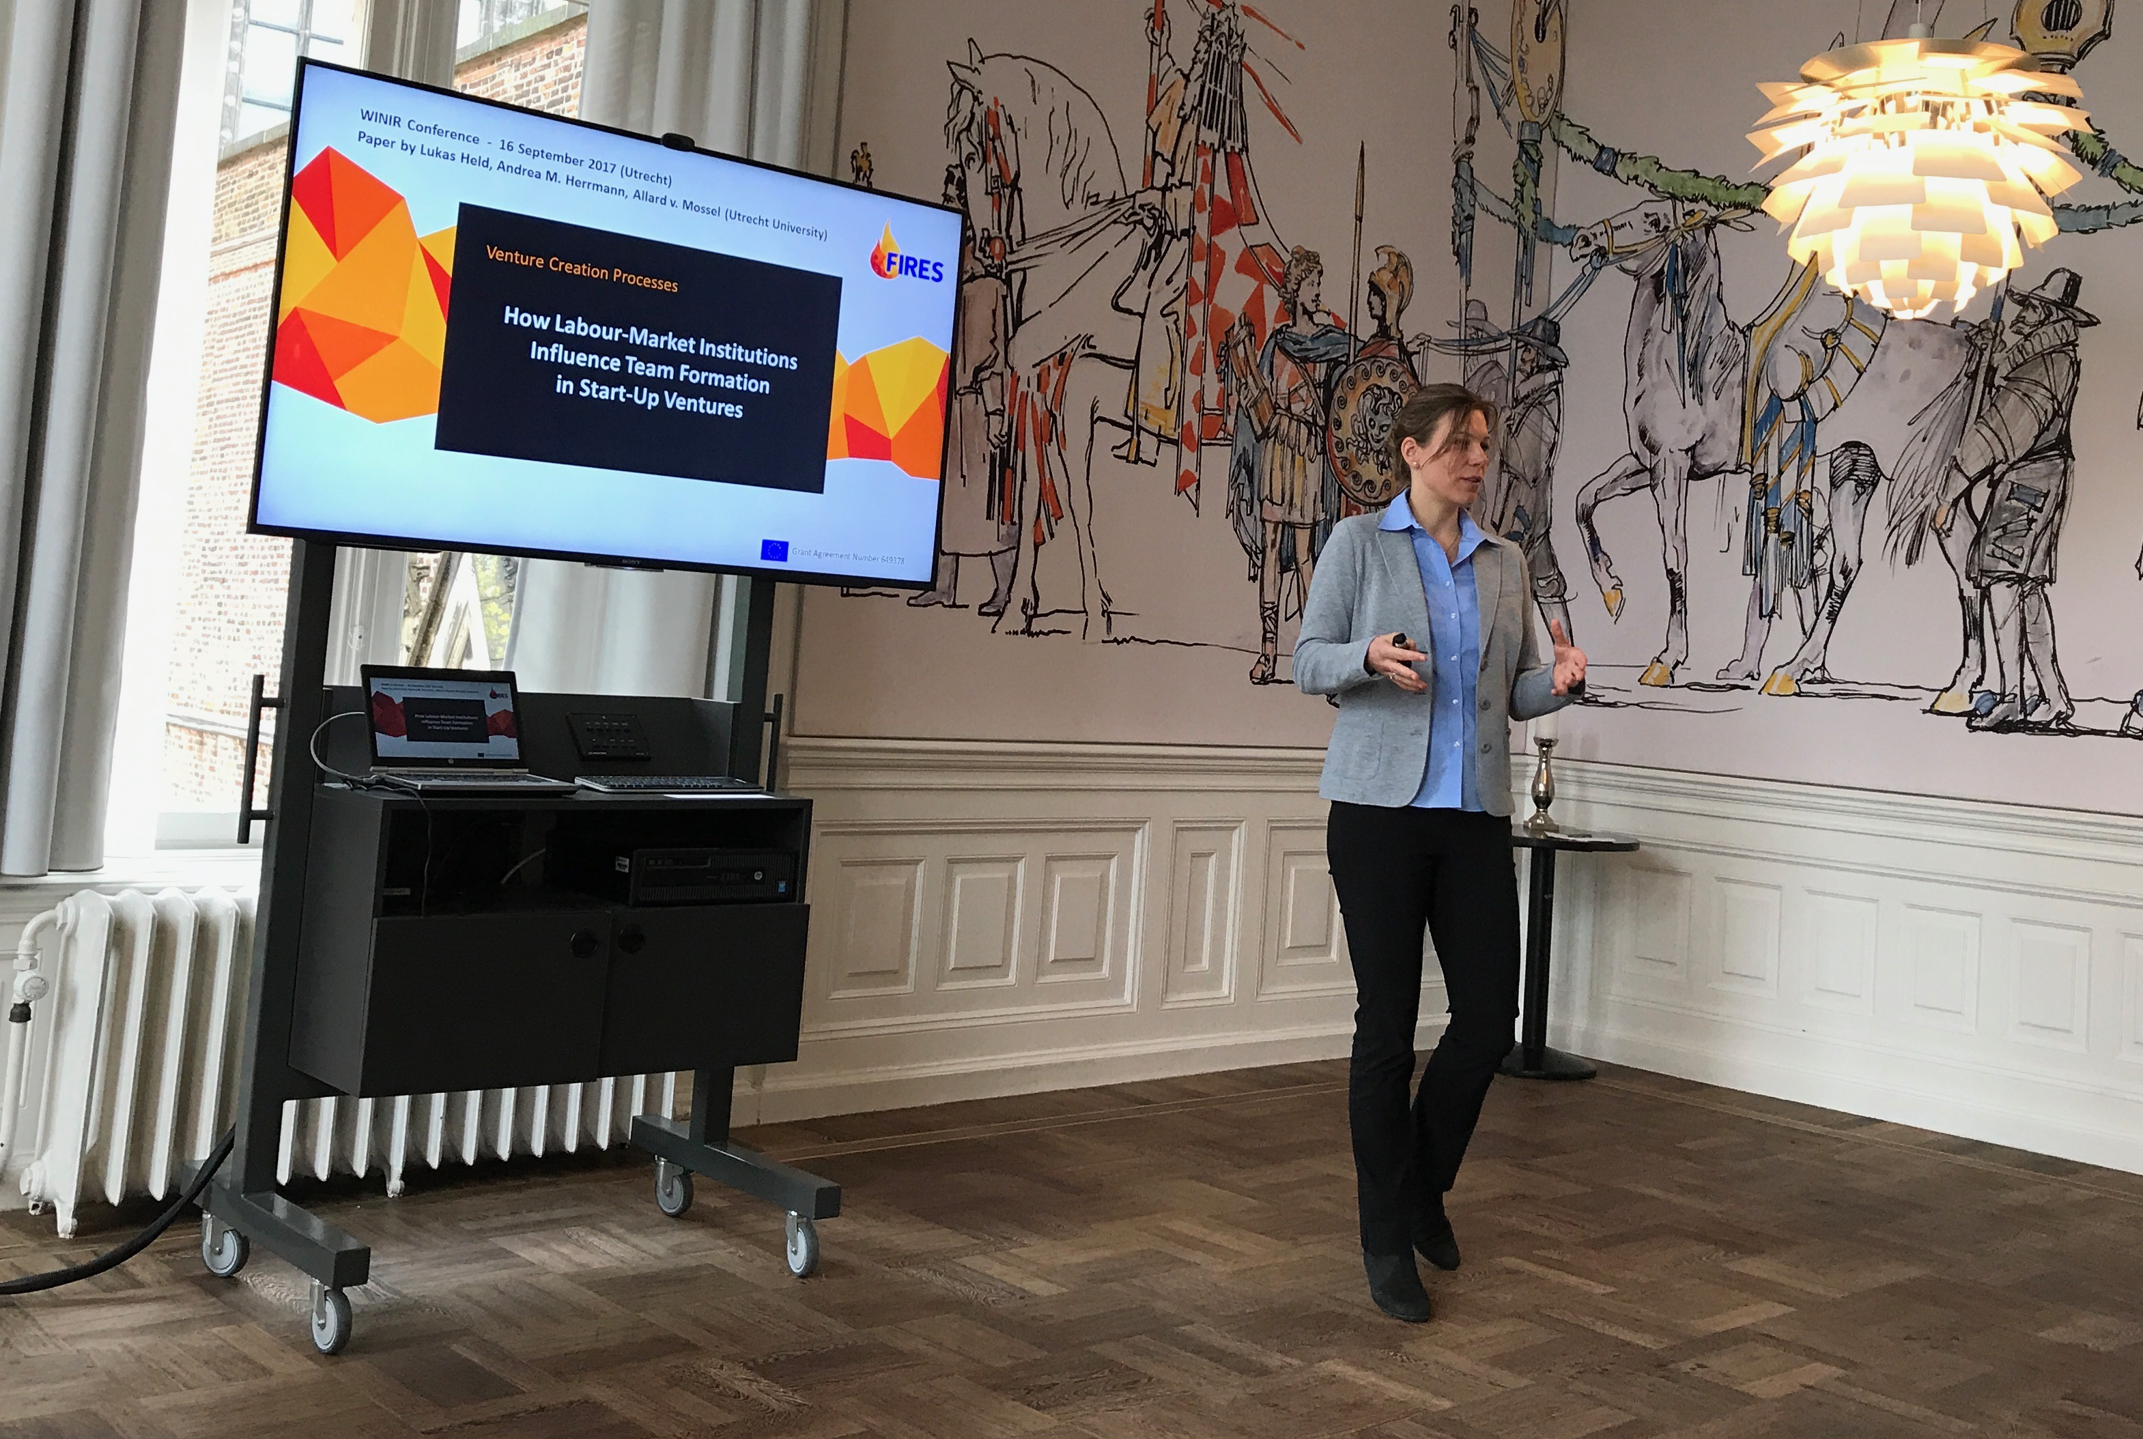
The presentation was well received by the audience and the findings were not fundamentally challenged. In particular, the team-formation typologies identified in the manuscript were perceived as substantially new insights to the entrepreneurship literature. Furthermore, the audience rightly pointed to the limitations of the paper: On the one hand, the R² of the regression analyses are comparatively low, highlighting the somewhat limited explanatory power of external corporate factors, including labour-market institutions. On the other hand, the audience would have appreciated some qualitative insights explaining the regression results presented. In response to these two comments, we will write a section on the limitations of the paper in the concluding section and provide qualitative evidence on possible causalities underlying the regression results obtained.

Jacob Jordaan Post materialism, institutions and economic growth (Sa 13:30-16:00)
This paper is not a formal FIRES-deliverable. The paper focuses on the interrelationships between and effects of social values and institutions on economic performance. In particular, it examines whether the degree of post materialism in a country impacts directly upon economic performance and indirectly via its influence on a variety of legal, economic and democratic institutions. Using data for a large cross-section of countries and deploying three stages least squares estimation techniques, our findings show that there is a negative direct effect of post materialism on economic performance, which can be explained by the growing importance of non-income-maximisation priorities. Institutions have a direct positive effect and also transmit a positive indirect of post materialism on economic performance. A comparison of the direct and indirect effects of post materialism shows that for most types of institutions the indirect effect outweighs the direct effect, indicating that, overall, post materialism fosters economic performance.

Follow Up
The comments specific to the papers mentioned above have been discussed in the author teams and have been addressed to improve the scientific quality of our work.

