# 

# 

# Policy Roundtable Report

Mark Sanders, Michael Wyrwich

# 

Document Identifier

Annex X to D5.12 The Reform Strategy for Italy, Germany and United Kingdom

Version

1.0

Date Due

M36

Submission date

01-05-2018

WorkPackage

5

Lead Beneficiary

UU

# Place, Date and Time

Berlin, 24-04-2018, 11:00-16:00, Bundesministerium Fuer Wirtschaft und Energie, Berlin, Germany.

# Stakeholders

See program

# Format

The round table was organised in blocks of two presentations with a general discussion round after each set of presentations. The FIRES-project was represented in two presentations. See the program in the flyer of the event below reproduced:



Participants were sent the Policy Brief on the FIRES-reform strategy for Germany one week in advance and asked to reflect on the questions below.

# Main Questions put to the Stakeholders

Would you agree with our approach?

Would you agree with our diagnosis?

Would you agree with the proposed treatment?

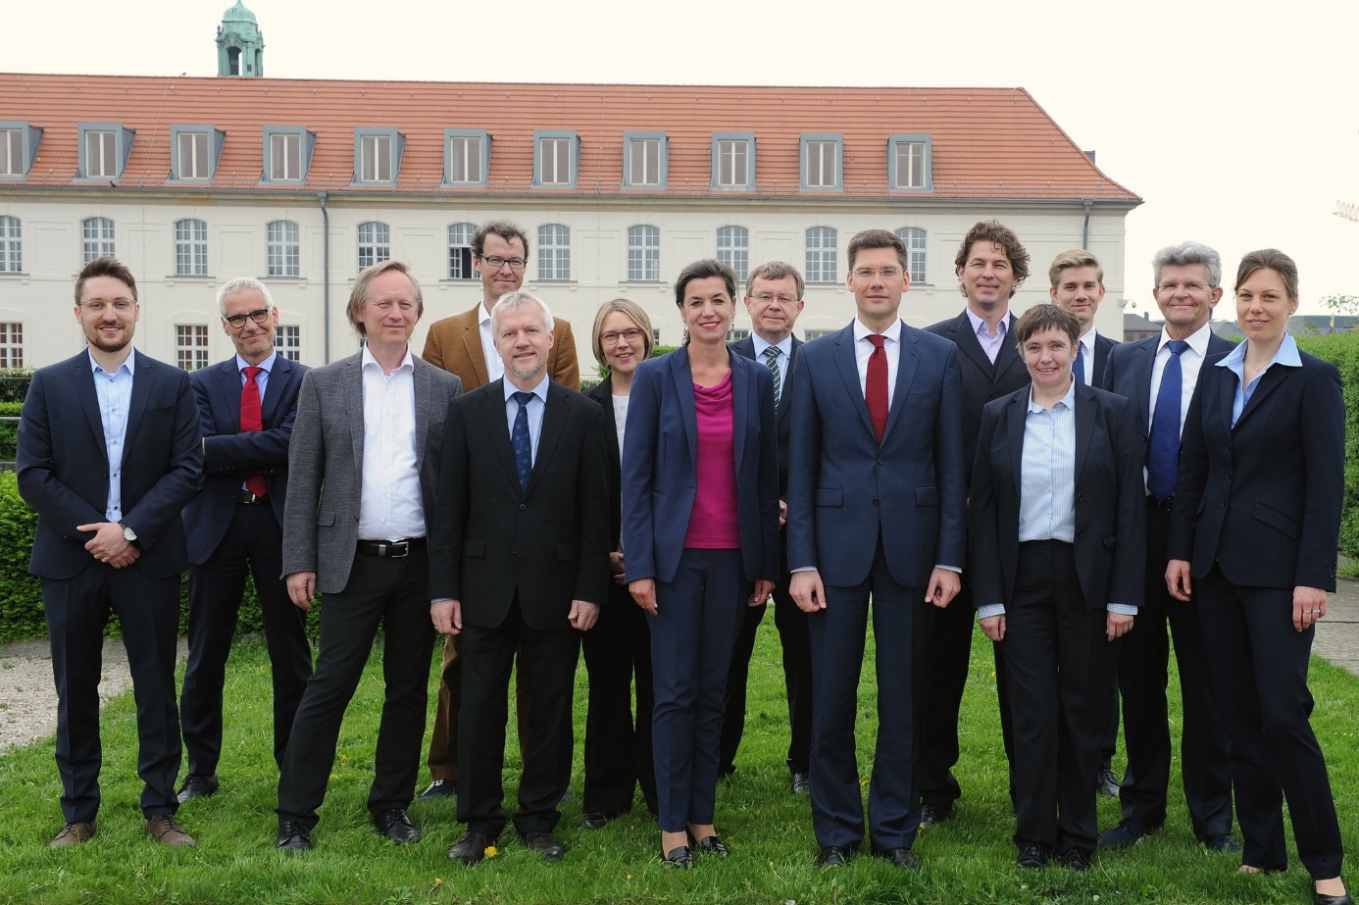

# Summary

**Round Table Mittelstand (Berlin 24th of April, 2018)**

The participants were welcomed by mr. Christian Hirte, Parliamentary State Secretary with the Minister of Economics and Energy and Germany’s SME Special Envoy, mrs. Hepperle. In an introductory note Friederike Welter, the president of the Institut fuer Mittelstandsforschung (IfM) outlined why SME policy needs new impulses. After kicking-off the Round Table Mark Sanders and Michael Fritsch presented the reform agenda for Germany that was developed in the FIRES project. The presentation involved an overview on fundamental institutional settings of the country and the position of its entrepreneurial ecosystem in an international comparison. The talk also touched upon regional differences within Germany. The bottlenecks of the German entrepreneurial ecosystems were outlined. In conclusion, the ecosystem apparently works rather well. Nevertheless, there is room for policy improvement. Mark Sanders mentioned different policy measures that could be helpful to promote entrepreneurship and the entrepreneurial society in Germany. The main message for Germany was that the German institutions could allow for more experimentation and radical innovation by strengthening the educational system and considering creating a more equal playing field between dependent employment and self-employment/employer when it comes to labour protection and social security. Germany could afford to become a bit more adventurous.

After the FIRES presentation two further talks were given. The first presentation was held by Peter Weiss from the Association of the German crafts and manufacturing trades. His main impetus was that the increasing documentation requirements for EU state aid regulation represent a stumbling block for firms in crafts and manufacturing trades. Current rules come along with a lot of bureaucracy creating unintended consequences, such as a severe drop in the participation rate in apprenticeship programs. The main take away of the presentation was that state aid regulation should be more flexible and allow for higher threshold levels for SMEs.

The final presentation of the first session was held by Klaus-Heiner Röhl from the Institute of the German Economy. He provided descriptive statistics on the SBE sector in Germany and Europe. He stressed that the SME definition of the EU should be handled more flexibly in order to promote SME growth. This should be accompanied by deregulation of documentation requirements. His emphasis was on so-called mid-cap companies with more than 250 but less than 3000 employees which are no SMEs by definition but operate under similar organizational routines and firm behaviour. According to the opinion of the Institute, the pivotal role of the Mittelstand for German economic development implies that such companies should be targeted as well in an entrepreneurial society.

The talks of the first session were followed by a lively debate. One of the patterns discussed was whether there needs to be indeed an adjustment of the size threshold of the SME definition or whether institutional reforms and a reduced bureaucracy are promising policy avenues. One issue of lifting up the SME threshold is that the budget has to be distributed among more firms. This was perceived as a problem of changing the SME definition. The discussion also revolved around the detrimental effect of (German) risk aversion on entrepreneurship. Several participants stressed that addressing such deeply rooted institutional/cultural patterns are more important than changing the distribution of budgets and changing definitions. An interesting train of thoughts that emerged in the discussion was that the high level of risk aversion that is observable in Germany is not innate but driven by the institutional architecture. Put differently, institutions like high employment protection and entrepreneurship-inhibiting insolvency laws increase the risks involved with entrepreneurial failure. Fostering a culture of accepting failure might be helpful but not pivotal for reducing risk aversion. Rather institutional reforms that decrease the personal risks of failure may be more promising.

In the second session after lunch, there were two further presentations. In the first talk, Michael Rothgang from the Rheinisch-Westfälischen Wirtschaftsforschungsinstitut (RWI) was presenting current trends in productivity among German Mittelstand firms. The RWI proposes several measures to increase the level of productivity. This implies a more efficient use of ICT in all production stages. The second talk by Marius Berger from the ZEW in Mannheim focussed on start-up investments by business angels. In particular, the focus was on the INVEST program of the German government. The program subsidizes venture capital investments by business angels. A novel feature is that not the company but the business angel investing the money is given the subsidy. It was outlined that the INVEST program reduced market failure in the seed stage. In most cases experienced business angels are investing but the program also supported so-called virgin angels which did not fund new innovative companies in the past.

The discussion focussed on several topics. One pattern was the effect of the angel investments on firm development. There is no detectable effect on firm productivity. Against this background, it was discussed whether the cultural effects of such a program are more important. Creating an environment where investing in highly innovative companies is well-accepted can have long-term effects, also in light of the earlier discussion on risk attitudes. Productivity effects might be observable in the long-run only. Apart from that, the idea to subsidize the investors and not the firms was regarded as a fruitful strategy. Mark Sanders draw the analogy to human capital investments. That is, policy makers subsidize formal qualifications while people decide where (in which industry) they utilize their human capital. With respect to the general productivity development of Mittelstand firms, it was noted that there is a huge variation in median and mean values that were shown in the first presentation of the session. One plausible explanation that was discussed is that digitalisation put firms under pressure and there is to date great variance in the degree to which firms are able to cope with this challenge.

In the last round of discussions opportunities for knowledge and idea exchange between Mittelstand firms and start-ups were highlighted in the first presentation. The presentation was held by Christof Starke from the RKW. In the second presentation Andrea Herrmann from the FIRES-project presented research results on different types of entrepreneurship across countries with distinct institutional frameworks. The talk demonstrated that institutional differences determine the type of entrepreneurship and the sort of innovation pursued by entrepreneurs (incremental vs. radical innovation). In this respect, Germany has an advantage in incremental innovation. Copying institutions from more liberal market economies may put this advantage at risk. According to Andrea Herrmann, promoting incremental innovations in Germany requires better finance for SMEs, reduced taxation of SMEs and relaxing regulation.

In the subsequent discussion, it was critically discussed whether capital access and tight regulations are indeed the bottleneck for start-ups. An important point that was raised is that varieties of capitalism would require also a variety in EU policies across member states. It was argued that copying the „Silicon Valley“-model would be ill-advised, but Germany and the EU cannot be complacent. The development of digital technology and the rise of China and its approach to improve existing technologies poses a strong threat for the development of Mittelstand firms and the German style-entrepreneurship.

In the final discussion the question was raised whether a *European* Mittelstand policy should be put on a future agenda. The representatives of the Ministry concluded that the Roundtable was very productive. A lot of ideas for future round tables could be developed based on the presentations by the FIRES team and the subsequent discussions.

# Follow Up

After the discussion with the German policy makers there will be a final revision of the policy brief and country report to be submitted as parts of deliverable D5.12 on M36. Also the discussion in Berlin serves as input for D6.3 in M36.